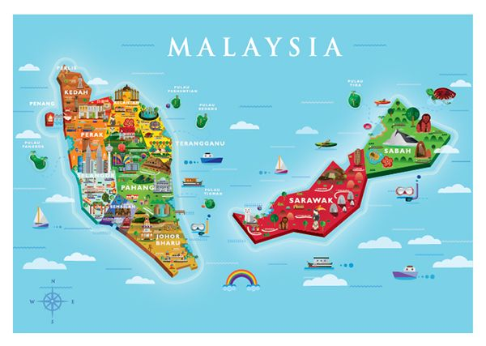

Malaysia – A Mosaic of Cultures
Malaysia lies in the heart of the Indian Ocean and shares a border with Thailand, Brunei and Indonesia. It’s a beautiful country full of coastal plains and mountains, and is also rich in cultural history. A wide range of ethnic groups represent Malaysia, which bring exceptional and interesting cuisine as well as its diverse expatriate heritage.
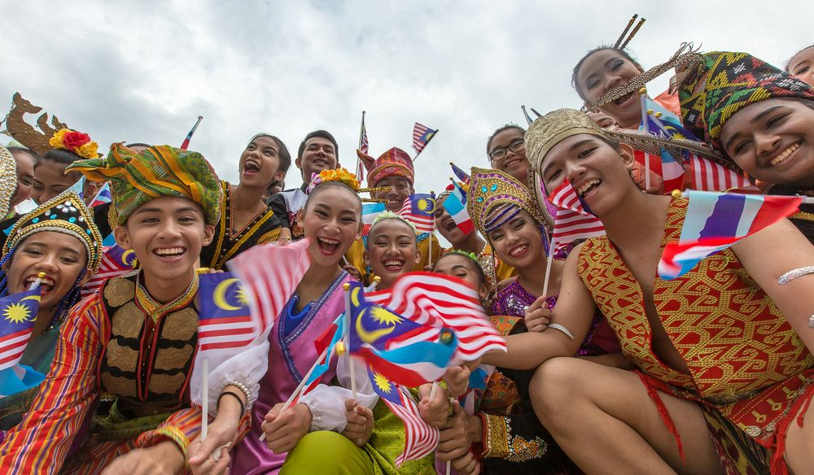

Culture
Malaysia is one of the most multicultural countries in South East Asia. The uniquely diverse people respect each other religions and traditions, which embraces a refreshing form of diversity.
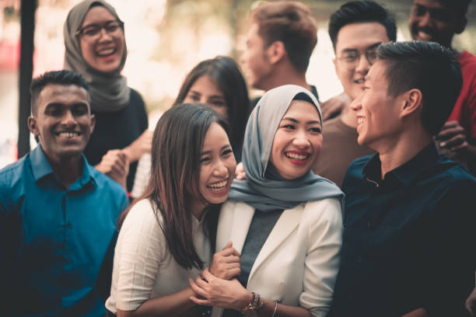

Family
Malaysians are very much family-oriented people and as a result they place great importance on unity, loyalty and respect for their elders. The family in Malaysian culture can guarantee both emotional and financial care and they have no qualms with marrying outside of their culture/religion.
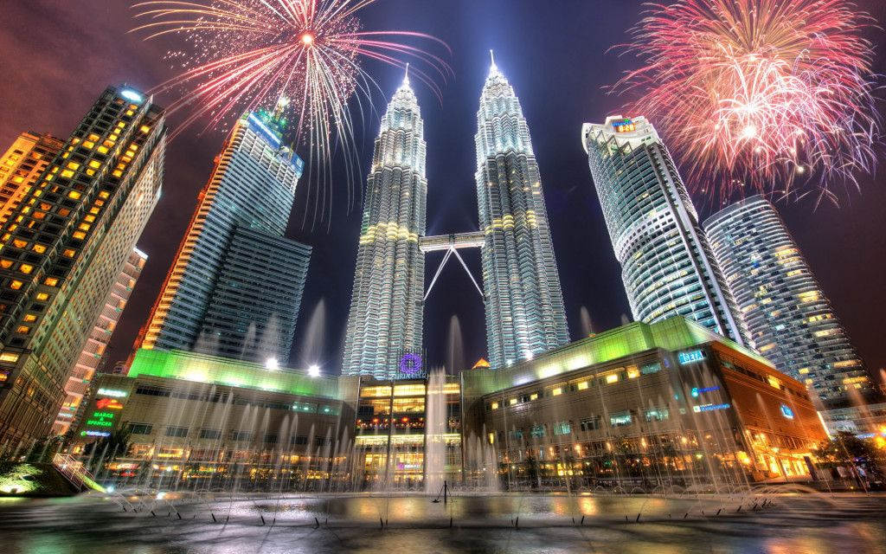

Festivals
Unique to Malaysia is the “open house” concept where ─ during the various cultural and religious festivals such as Chinese New Year, Hari Raya Puasa, Deepavali and Christmas ─ friends, families and even strangers would visit the homes of those who are celebrating the festival, to wish them well and enjoy the feast prepared by their hosts.

Hari Raya Puasa (Eid Ul-Fitri)
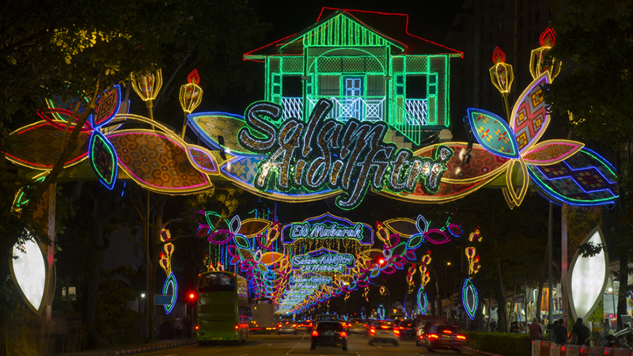
The most significant celebration for Muslims, Eid Ul-Fitri, marks the end of the fasting month of Ramadan. The words ‘Hari Raya’ means day of celebration in Malay language. The celebration is determined by sighting of the new moon on the day before the next month on the Muslim calendar, Syawal.

Deepavali/ Diwali
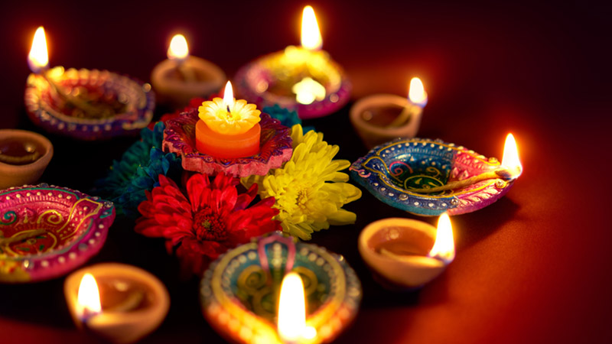
Celebrated by Hindus as the day the evil Narakasura was slain by Lord Krishna. Signifying the triumph of light over darkness and good over evil. Deepavali is also known as Diwali, or the Festival of Lights. Light is significant in Hinduism because it represents goodness.

Thaipusam
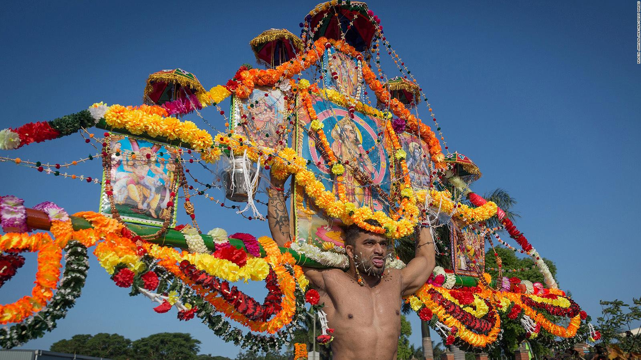
Hindus celebrate Thaipusam on the tenth month of the Hindu Lunar Calendar. Thaipusam is a Hindu festival celebrated mostly by the Tamil community on the full moon in the Tamil month of Thai (Jan/Feb). The festival is best witnessed at Batu Caves in Kuala Lumpur and in Penang.

Religion

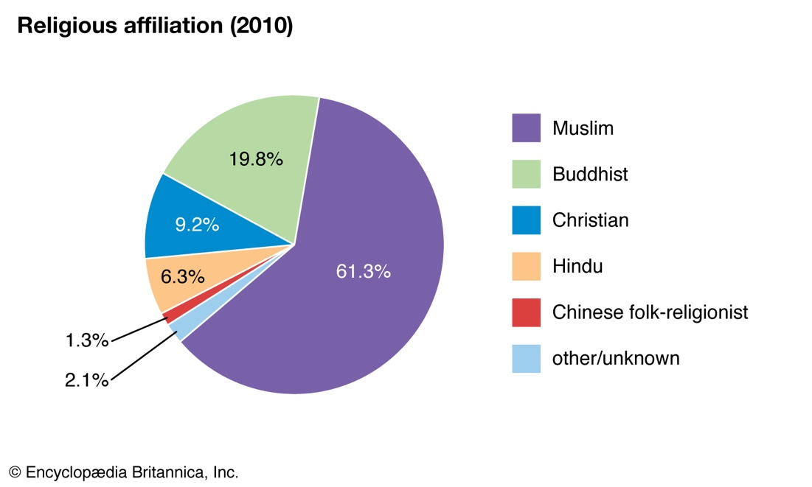
Malaysia official religion is Islam and 60% of the country are Muslim, but the country also has Hindu and Buddhist populations. Chinese Malaysian also follow Taoist and Confucianist traditions and tribal people in Borneo and other remote areas follow traditional animist beliefs.

Language
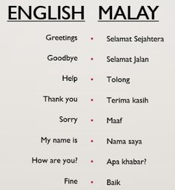
The national and official language of Malaysia is Bahasa Melayu. English is, because of the colonial past, also widely spoken. Other languages such as Chinese, Iban and Tamil are spoken by the minorities of Malaysia.

Landscape
Malaysia is divided into two distinctive areas, with an equatorial climate, having both a monsoon and a dry season.

WESTERN MALAYSIA
Kuala Lumpur
The capital and largest city of Malaysia is boasting with gleaming skyscrapers, colonial architecture, charming locals, and a myriad of natural attractions. Kuala Lumpur is widely known for the world’s tallest twin skyscrapers, the iconic Petronas Twin Towers.
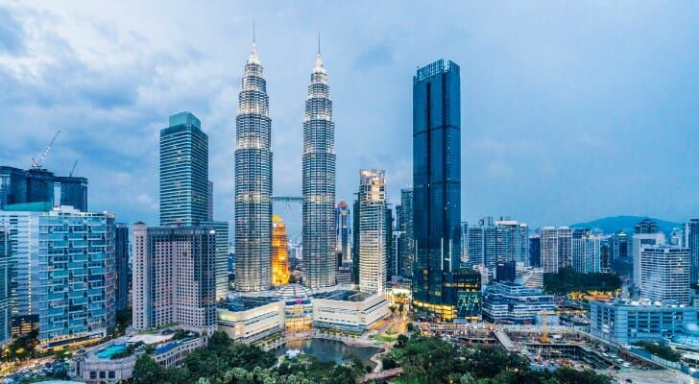

Langkawi
Langkawi is an archipelago made up of 99 islands on Malaysia’s west coast. Surrounded by turquoise sea, the main island is a mixture of picturesque paddy fields and jungle-clad hills. The tropical island offers the perfect opportunity to dive in Malaysia's crystal-clear water.
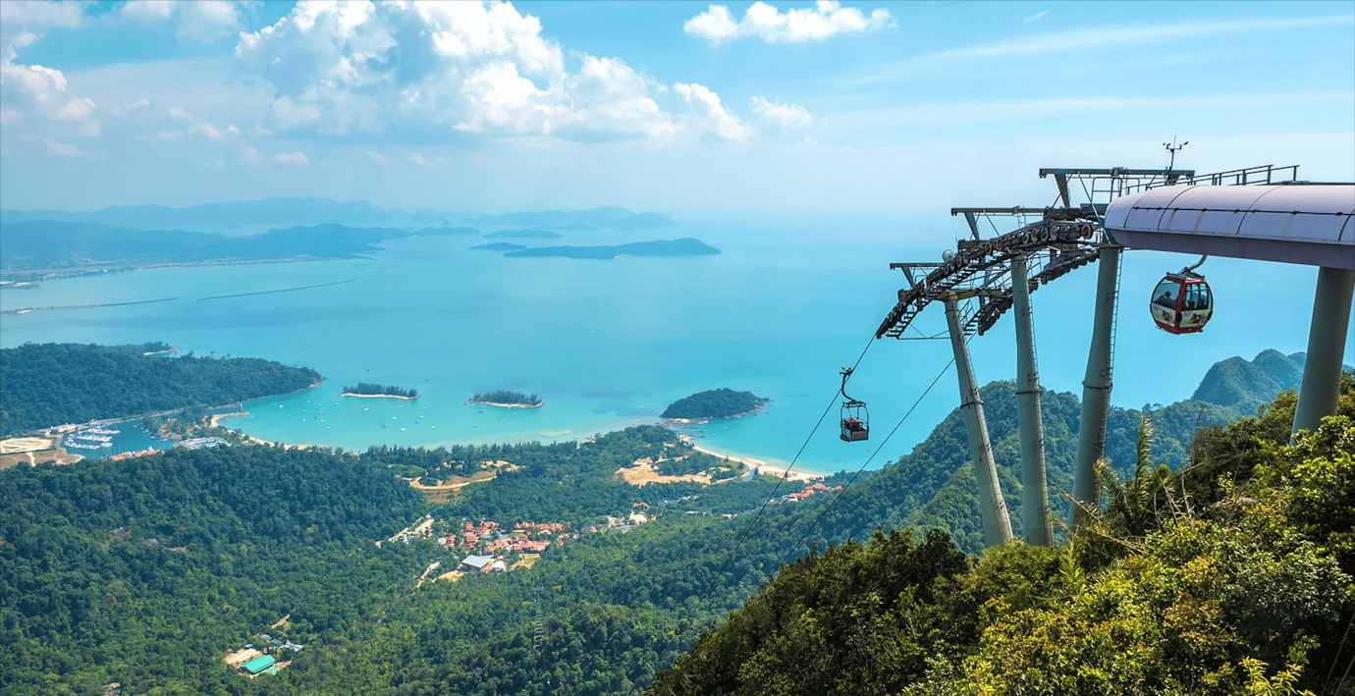

Penang
Once upon a time this world-renowned destination was known, as Pulau Pinang or the “Isle of the Betel Nut”. This exotic paradise is full of cultural sights and natural scenery ranging from modern art districts to incredible vipers in the Snake Temple.
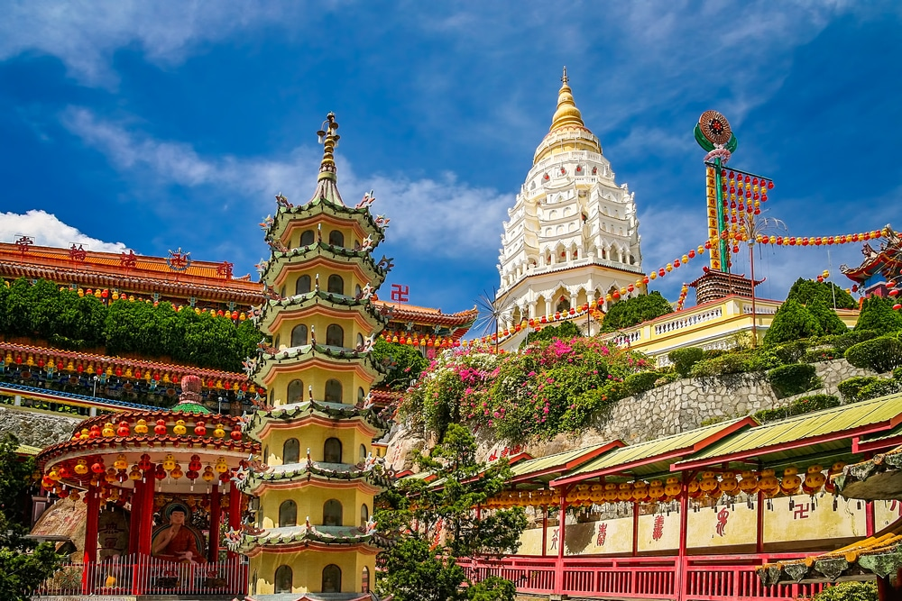

Malacca
A well-restored city with an abundance of breathtaking sights and rich heritage. Malacca possesses an eclectic blend of customs, traditions, food and lifestyle. Malacca also thrives with terrific scenery such as the Ayer Keroh’s lush greenery and the Malacca City’s urban landscape.
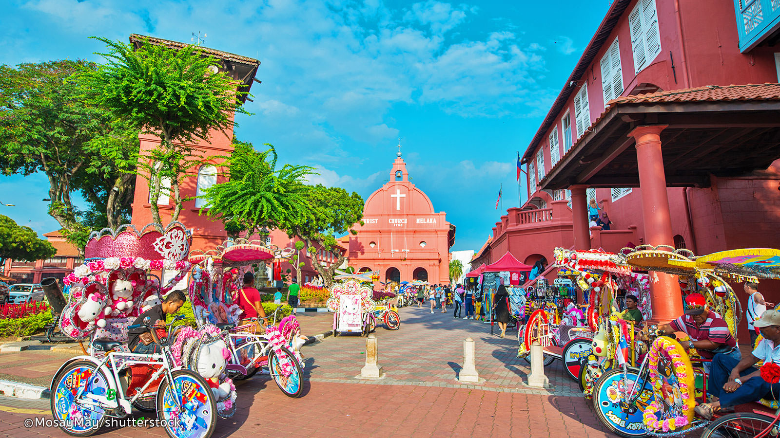

Redang Island
Redang lies within protected marine waters, also known as Terengganu Marine Park. It is surrounded by many other smaller islands and crystal-clear water. The coral reefs are vibrant and perfect for water activities like snorkeling or diving.
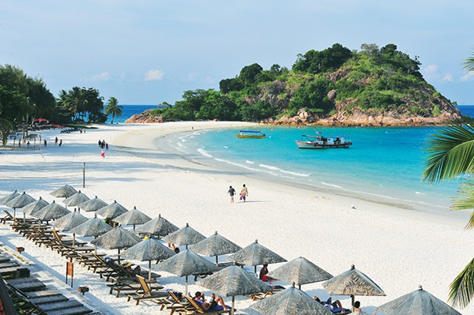

Perhentian Islands
The word “perhentian” in Bahasa Malaysia means “stopping point”. Make a stop in paradise and admire the staggering beauty of the fine sand beaches, crystal-clear water and the thriving marine life on the Perhentian Islands.
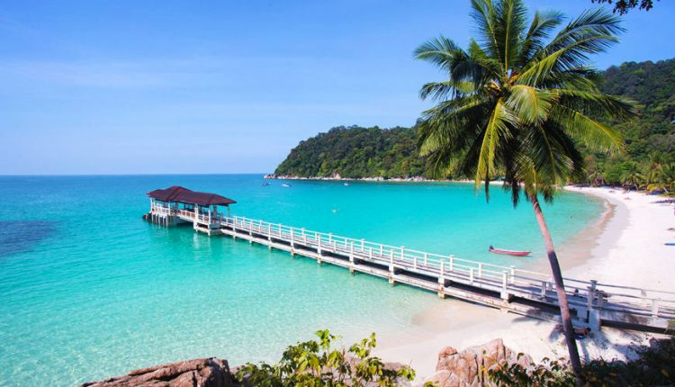

Tioman Island
Tioman Island first became famous as the shooting location for the film South Pacific in 1958. The island was chosen to represent ‘Bali Hai’ thanks to its amazing white sand beaches and its azure waters.
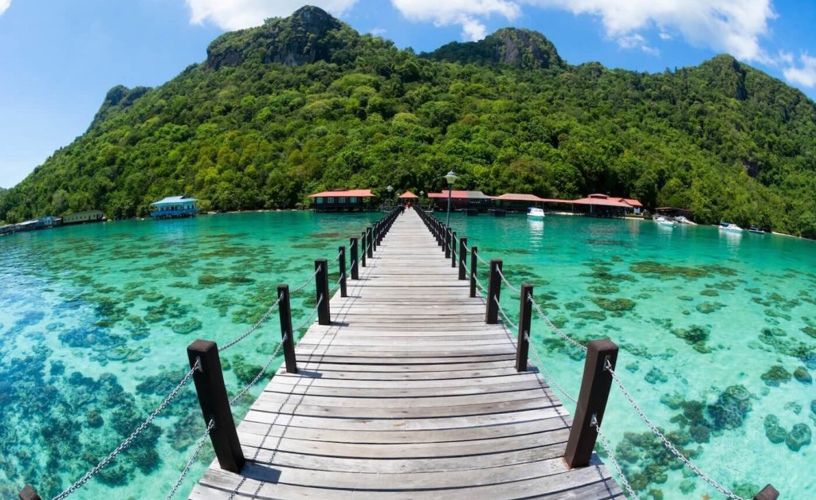

EASTERN MALAYSIA
Distinct from Peninsular Malaysia which houses the capital city of Kuala Lumpur, East Malaysia has a completely different feel to it, and many people come here to take in a more rural side of the country, with lush jungles and towering peaks aplenty.

Kota Kinabalu
Kota Kinabalu is the charming capital city of Sabah which is part of East Malaysia. Mount Kinabalu and other beautiful rural sceneries are the perfect excuse to leave the city for an adventure filled with scenic train journeys, bubbling hot springs, and winding river cruises through mangrove swamps.
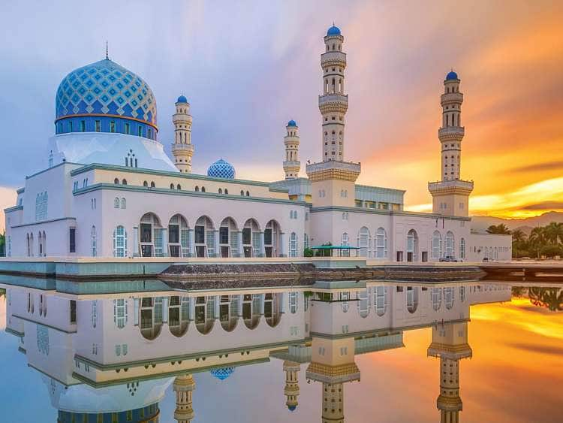

Sandakan
Sandakan is famous for the famous Sepilok Orangutan Rehabilitation Centre which rescues and rehabilitates these incredible creatures. Learn more about the wildlife living in the gorgeous rainforests of Malaysia and explore the enormous Gomantong Cave.
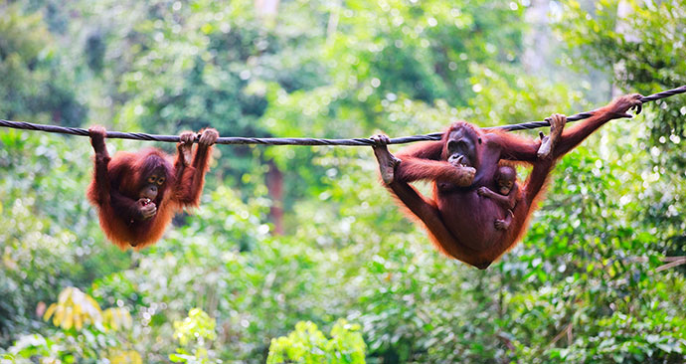
Semporna
Semporna means “perfect” in Malay. After a short boat journey to the Semporna Archipelago, dive into the clear and calm pine-green sea water.
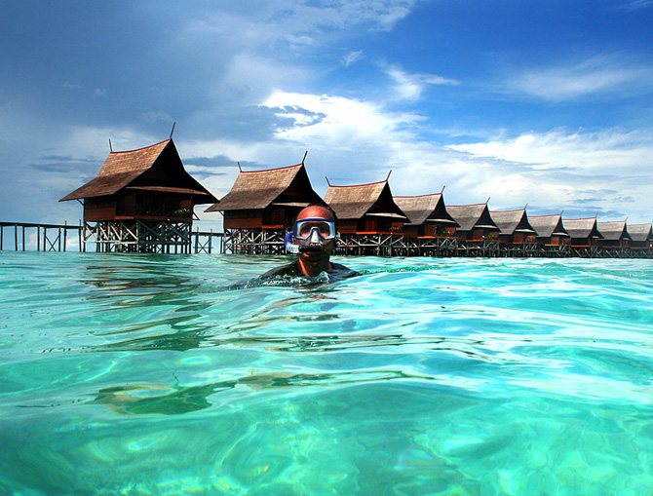

Kuching
Kuching is the home to many indigenous groups such as the Iban and the Dayaks. One highlight of this region is the Sarawak Cultural Village and the Bako National Park. Discover the unique culture and history of this old colonial town.
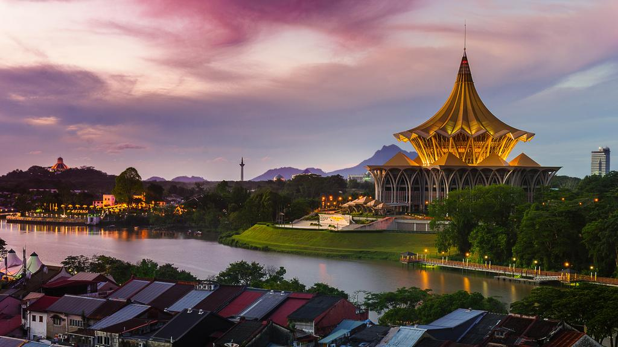

Cuisine
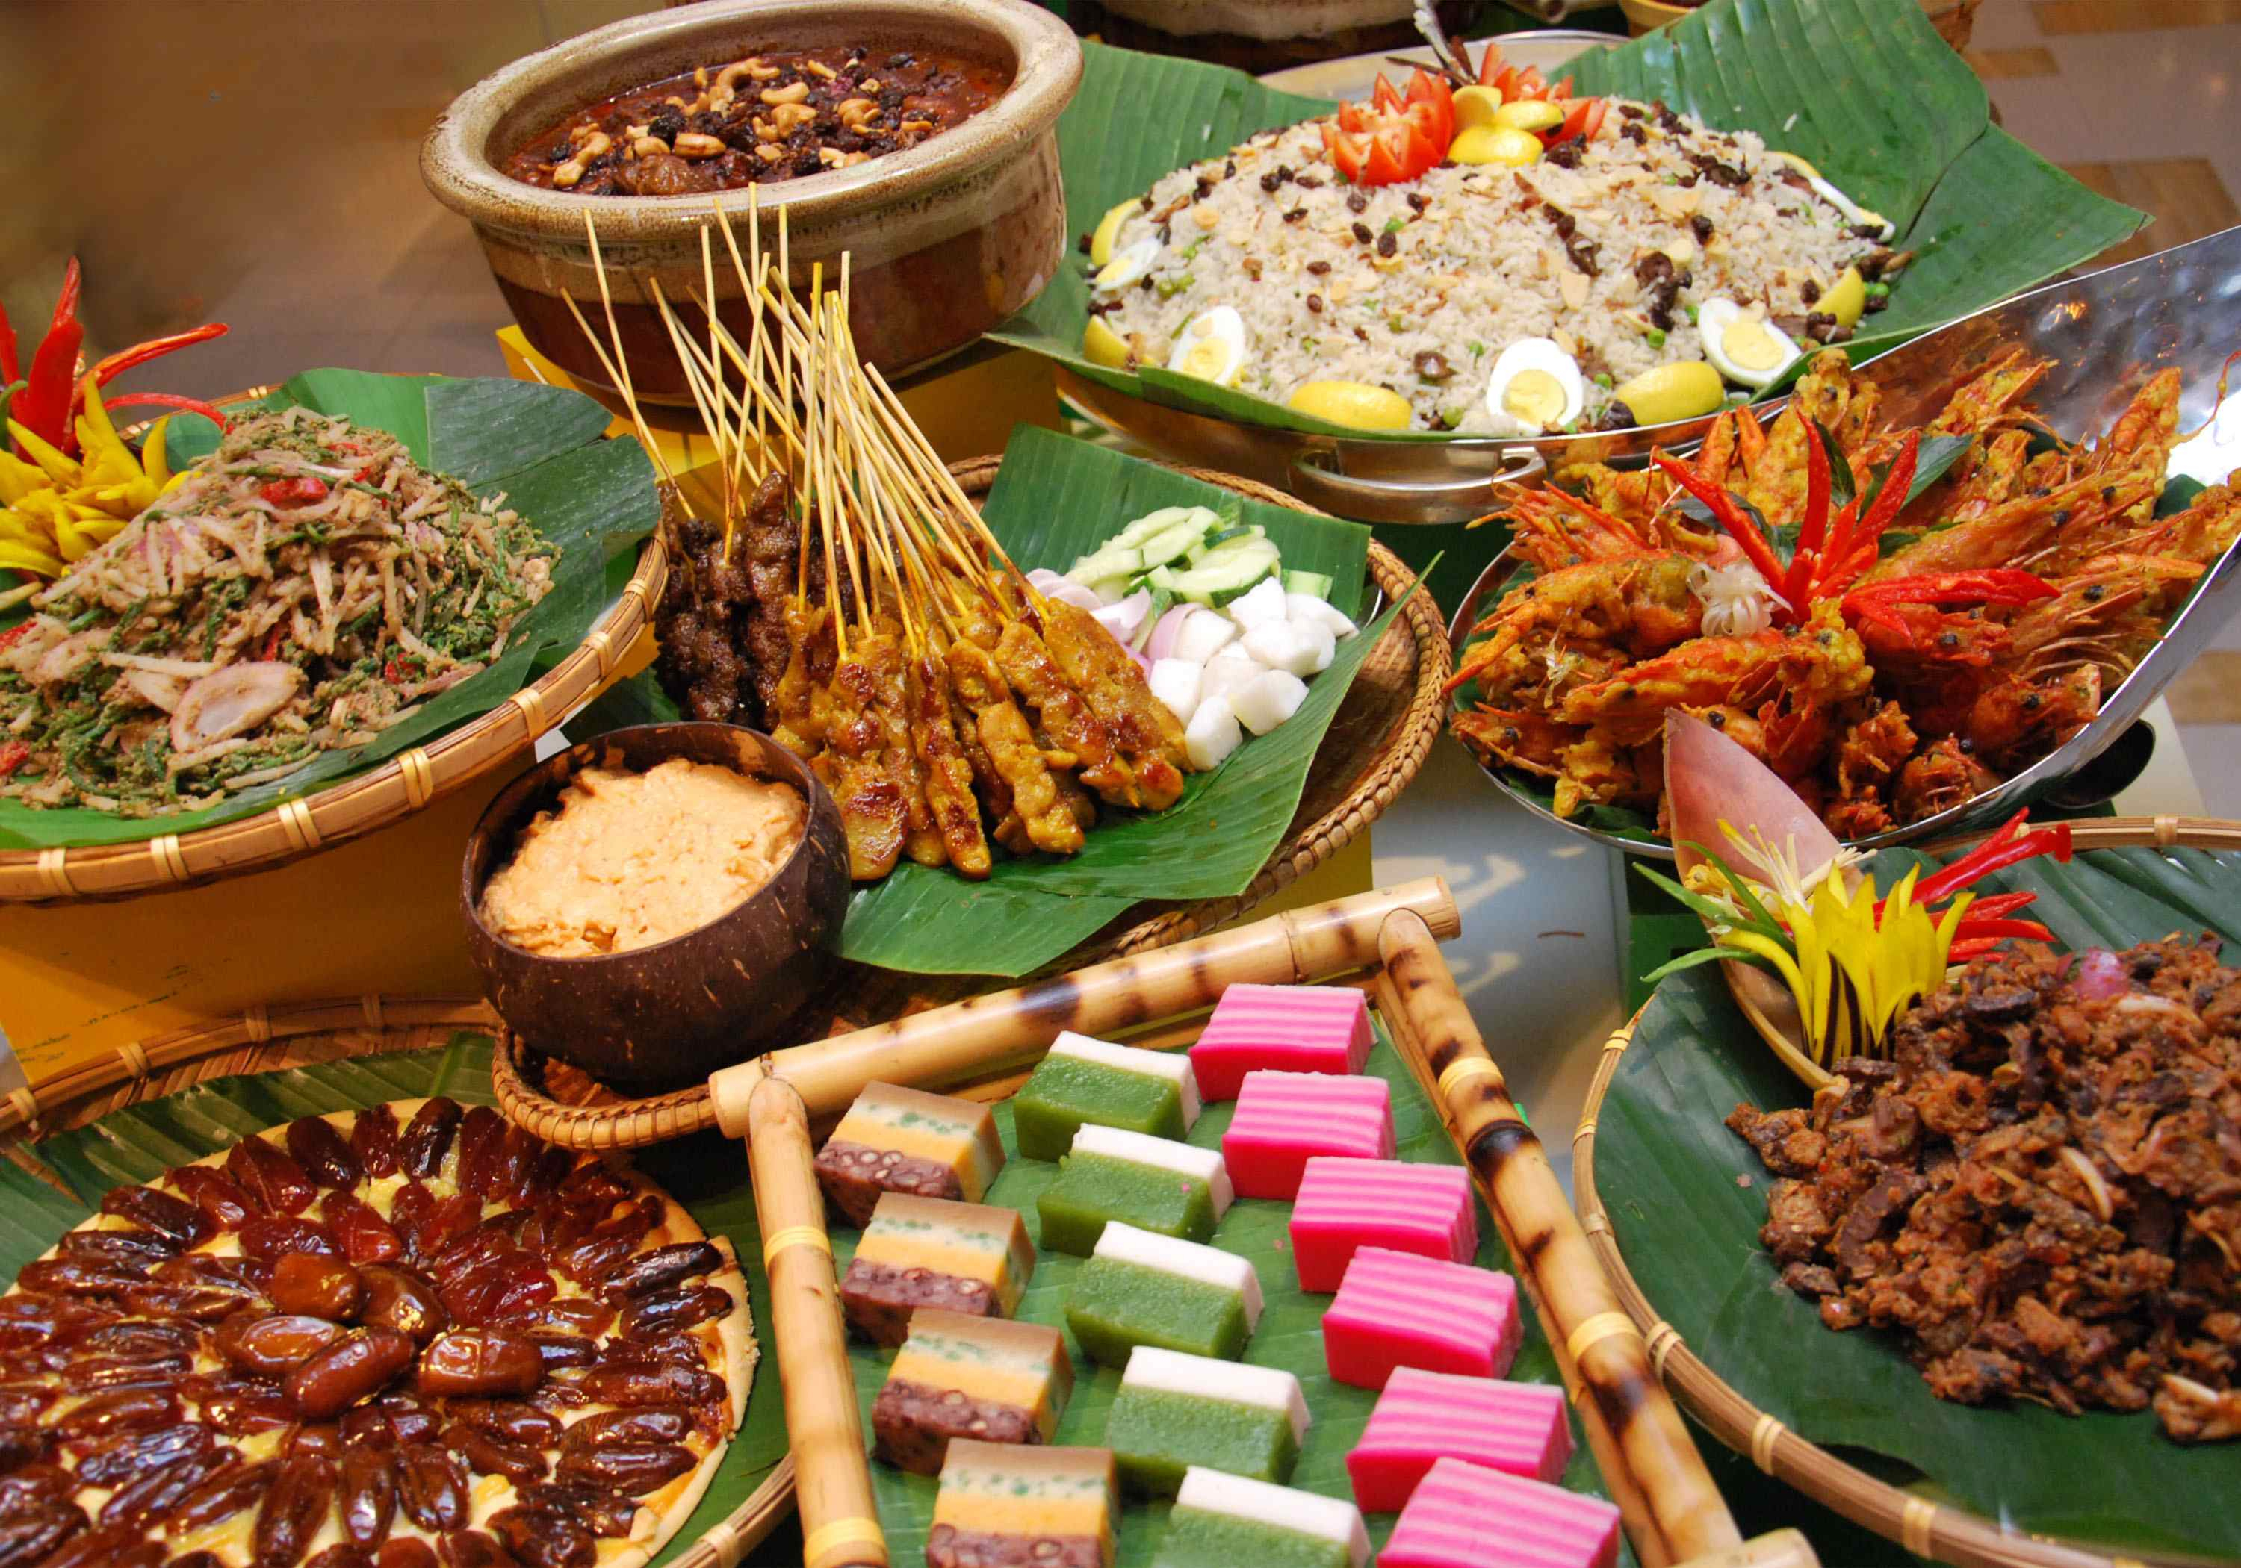
Malaysia is a melting pot of cultures, which is why it inherits a vast array of cuisines. This unique food diversity and mix of cuisine is remarkable. The people here are very passionate about their food and here come a few must-try's!
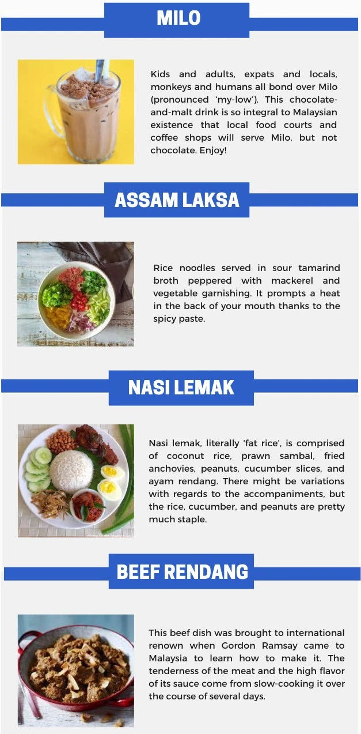
Souvenirs

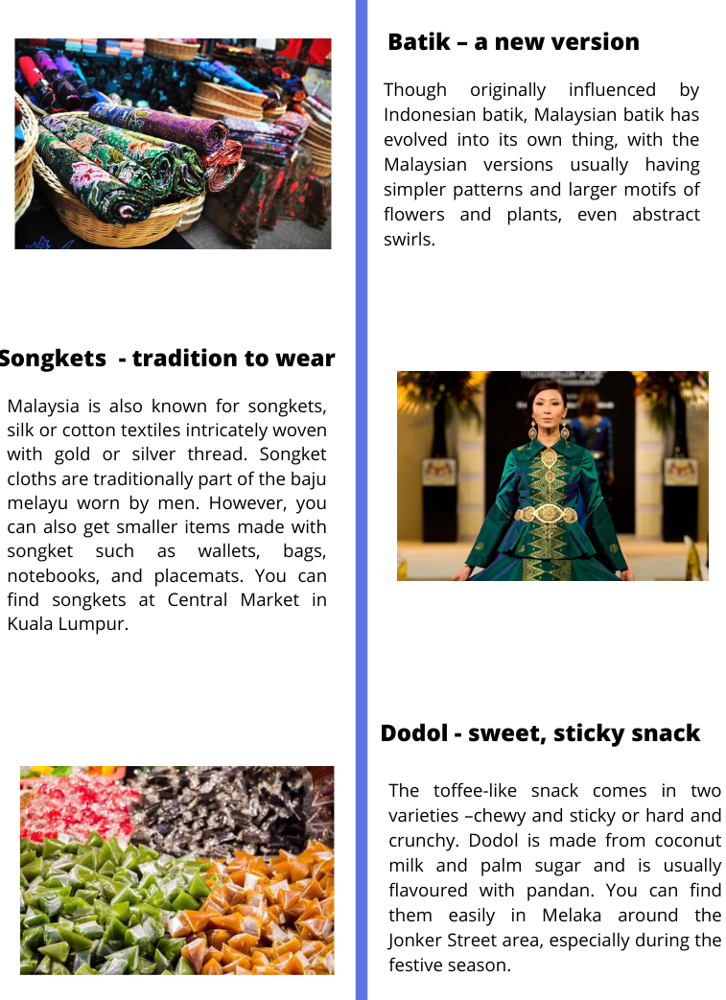

Malaysia with Children
Kota Kinabalu, also known as KK, is a perfect destination for families. The activities range from White-water rafting and visiting the Orangutan Sanctuary to hiking Mount Kinabalu. A visit to the Mari Mari Cultural Village is a fascinating experience for both, adults and children. After a day filled with joy, relax at a local seafood restaurant and enjoy the incredible sunset.
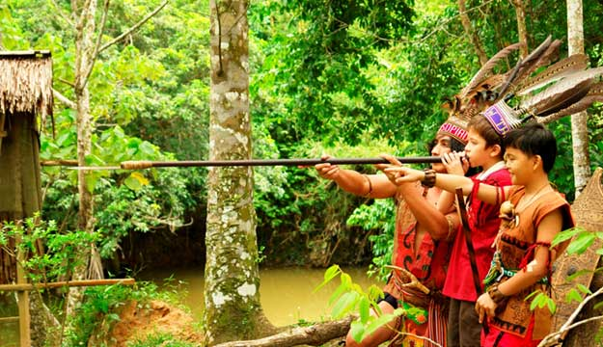
Mari Mari Culture Village

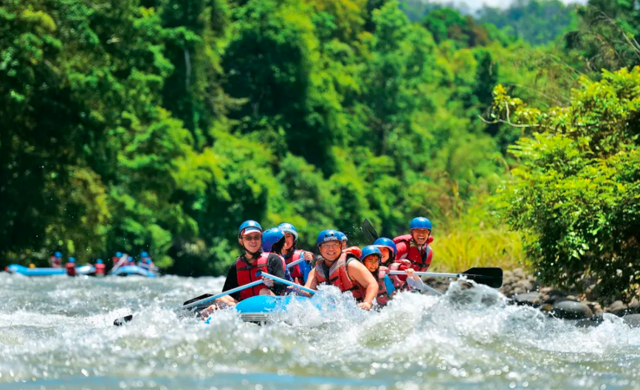
White – water rafting

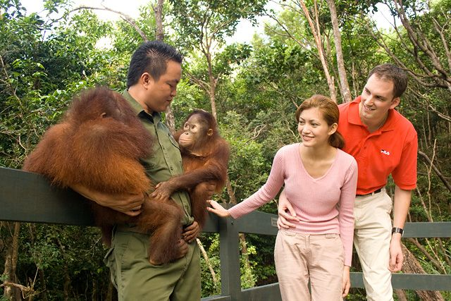
Orangutan Sanctuary

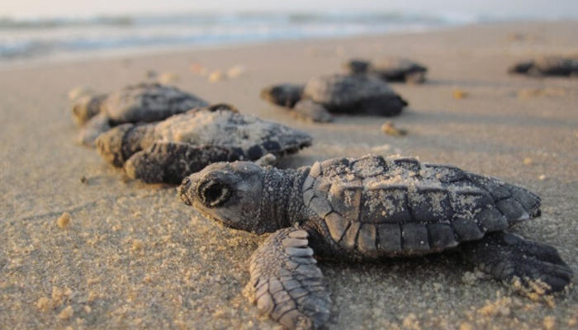
Turtle Island National Park

Must-see for first time visitors – the Proboscis Monkey
The Proboscis monkeys are endemic to the jungles of Borneo, never straying far from the island’s rivers, coastal mangroves, and swamps. The fleshy, pendulous nose of the male is supposed to impress females and intimidate rival males. Not only are they great swimmers, they also jump into the water with a comical belly flop. Visit these incredible creatures and help to protect their home, the rainforest.
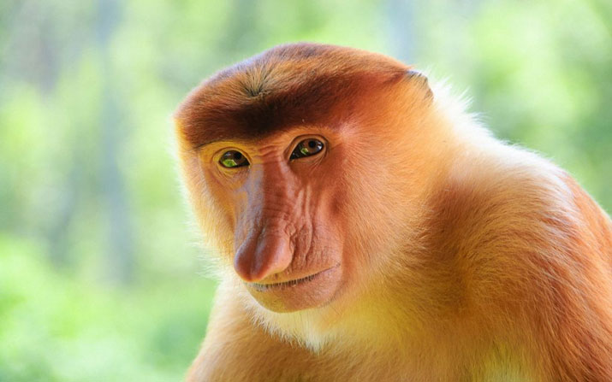

Top Itinerary

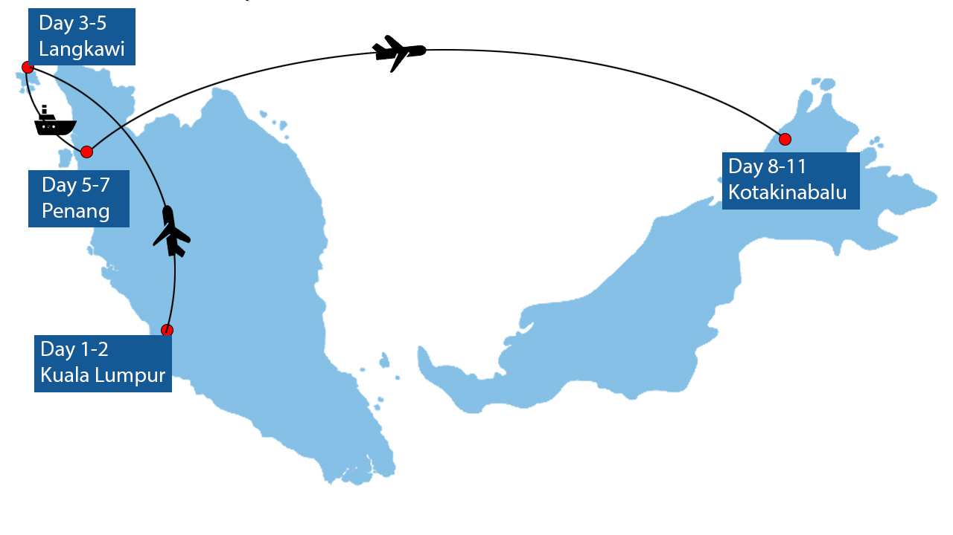
11-Day Classical Tour to Iconic Malaysia

Dive in the diverseness of Malaysia renowned among the world’s most beautiful countries and best food havens. From the capital city of Kuala Lumpur, to the archipelago of Langkawi, all the way to Penang state and Kota Kinabalu city, you will have plenty of time to enjoy an amazing journey throughout the country with this 11-day exclusively designed package by Expats Holidays.

Best time to go
With different weather patterns in different parts of the country, one could say that the best time to visit Malaysia is any time.

Malaysia has an equatorial climate meaning it’s hot and humid throughout the year. Average temperatures range from 20-30° and the relative humidity is an average 80%. Although climate change in recent years makes this less predictable, monsoon season still strikes the east coast in late October and sticks around through February. We do not recommend travelling to the east coast from November through February.
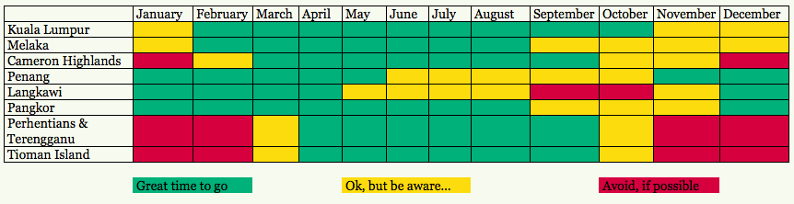

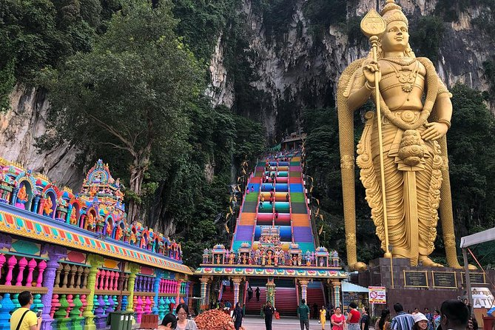
Travel tips
- Jetlag? Go shopping in the evening. The malls are typically open until 10 p.m. on weekdays, and even later on the weekends.
- Don’t wear your shoes indoors. Wearing shoes indoors is considered to be rude, offensive, and just plain dirty. Don’t do it.
- Some places might only have squat toilets. Be prepared and bring essentials.
- In Malaysia, it’s normal to eat with your bare hand, just remember to always eat with your right hand. Your left paw is reserved for less-savory things.
- Public displays of affection, such as kissing and fondling, are not encouraged. Be intimate as much as you want... inside your hotel room.

Visa
Many foreign travelers holding a passport valid for at least six months are granted visa-free entry to Malaysia. The other foreign nationals can apply for an electronic visa to enter Malaysia. Applicants will receive their visas via email, after filling the application form with the necessary information and once the online credit card payment is completed.
